EPMS Security Architecture
EPMS adopts a Zero Trust security architecture in which no request is trusted by default. Users authenticate through an enterprise Identity Provider using OAuth2 / OpenID Connect with MFA for privileged roles. Requests traverse edge protection and API entry controls ( Api Gateway) before reaching the BFF layer, where JWT is validated for journey-level access.
Domain microservices validate JWT again for service-level protection and enforce fine-grained authorization based on roles, ownership, business context, and workflow state.
All data in transit is protected using TLS, including user to application, service to service, and application to database communication.
All data at rest is encrypted using managed controls, with centralized key and secret management on AWS through services such as KMS and Secrets Manager.
Security events, admin changes, and sensitive business actions are logged and monitored centrally to support continuous verification and auditability.

Key Security Architecture Characteristics
Following are the key security architecture considerations for EPMS.
- Zero Trust security model
- OAuth2 / JWT authentication
- RBAC + ABAC authorization
- API Gateway security enforcement
- Encryption for data at rest and transit
- Centralized secrets management
- Cloud security services
- monitoring and audit logging
- DevSecOps security scanning
- Compliance with industry standards
EPMS follows a Zero Trust security model, meaning no user, device, workload, or network path is trusted by default. Trust is established continuously through identity verification, token validation, authorization checks, encrypted communication, and centralized monitoring.

1. User and identity entry
Users such as Business Partners, Project Managers, Governance Heads, CoE Heads, and Admins access EPMS from web or mobile clients. Authentication is performed by the enterprise IDAM / Identity Provider using OAuth2 / OpenID Connect, with MFA enabled for privileged roles and sensitive actions.
After successful authentication, the IdP issues a signed JWT access token. Spring Security’s resource server model is designed for exactly this delegated bearer-token pattern.

2. Edge protection layer
Incoming traffic first reaches the edge security layer, implemented in AWS using services such as CloudFront, AWS WAF, and DDoS protections. This layer provides TLS termination, request filtering, bot/WAF rules, and rejection of malformed or abusive traffic. It is the first checkpoint, but not the trust boundary. In Zero Trust, deeper layers must still verify and authorize every request. AWS recommends protecting data in transit to preserve confidentiality and integrity.

3. API entry layer
Traffic then reaches the API entry layer, typically an API Gateway, ALB, or ingress controller. This layer performs coarse validation such as ensuring bearer-token presence, applying throttling, generating correlation IDs, and routing requests to the correct backend entry point. It can reject obviously invalid requests early, but it does not replace downstream authorization. This aligns with layered AWS security guidance.

4. BFF layer
The BFF acts as the journey level security layer. It validates the JWT, verifies the signature using the IdP’s public keys discovered through the issuer or JWK Set configuration, checks expiry and issuer/audience, and builds a trusted user context before any controller logic runs. Spring Security supports this using OAuth2 Resource Server with issuer-uri and automatically validates JWT bearer tokens through IdP metadata and JWKS discovery.
At this layer, EPMS enforces:
- journey and screen access
- high-level role checks
- coarse workflow access
- user-context construction for downstream calls
This is the first explicit EPMS defence in depth checkpoint: the BFF validates JWT for journey level access.

5. Microservice layer
Requests from the BFF then go to EPMS domain microservices such as Program, Project, Planning, Governance, and Configuration services. Each microservice independently validates the JWT again, or validates a trusted propagated identity according to the chosen pattern, and performs service-level authorization. This implements EPMS defence in-depth principle that microservices validate JWT again for service-level protection. Spring Security’s resource server support allows each microservice to validate JWT locally rather than relying on a central session store.

At this layer, EPMS enforces:
- fine-grained RBAC
- ownership checks
- business-unit constraints
- approval-stage rules
- action-level permissions
This matches Zero Trust guidance that access decisions should be resource-centric and continuously enforced rather than assumed from network location.

6. Service-to-service trust
Even internal service calls are treated as untrusted. Communication between BFF and microservices, and between microservices themselves, is secured with TLS.

7. Data layer protection
EPMS data is stored in components such as Amazon RDS PostgreSQL, caches, backups, and logs. Security at the data layer includes least-privilege access, schema or domain isolation, immutable store, encryption of all sensitive records.

Data in transit
All connections to databases, object storage, caches, and external integrations must use encrypted transport such as TLS. This protects confidentiality and integrity for traffic between services and storage systems.

Data at rest
All persistent EPMS data should be encrypted at rest, including:
- transactional data
- documents and attachments
- exports and reports
- backups and snapshots
- logs and audit trails
- secrets and credentials
On AWS, this is implemented using KMS-backed encryption in services such as RDS, S3, EBS, and Secrets Manager. AWS’s key management guidance emphasizes storage, rotation, access control, and monitoring of key material.

8. Secrets and key management
All secrets, credentials, and encryption keys are centrally managed. Database passwords, API keys, integration credentials, and certificate material must never be hardcoded into EPMS services or pipelines. On AWS, Secrets Manager and KMS provide centralized management, rotation, and auditing of secrets and keys.

9. Monitoring, logging, and audit
EPMS security is continuously monitored through centralized logs and findings. Authentication events, authorization denials, admin actions, approval actions, and sensitive configuration changes are logged and correlated.
On AWS, this maps to CloudTrail, CloudWatch, GuardDuty, Security Hub, and optionally Security Lake for aggregation. Continuous visibility is a core operational aspect of Zero Trust.

Architecture flow

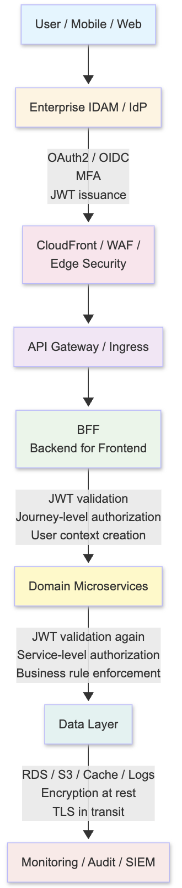

AWS Mapping for EPMS

- CloudFront + WAF for edge protection
- API Gateway or hardened ingress for API entry
- BFF on ECS / EKS / EC2
- Microservices on ECS / EKS / EC2
- RDS PostgreSQL for transactional data
- Opentext for attachments, exports, and documents
- KMS for encryption keys
- Secrets Manager for secrets
- CloudTrail / CloudWatch / GuardDuty / Security Hub for visibility and detection

